## Restaurant, cuisine, customer based advanced SQL analytics

Below are the steps executed starting from creating database, table and then inserting data into table. Later, I carried out writing advance SQL queries to address different business scenarios using Mysql.

**1) create the database project2**

CREATE DATABASE project2;

**2) Create the orders table**

CREATE TABLE project2.orders

(

Order_id VARCHAR(20),

Customer_code VARCHAR(20),

Placed_at DATETIME,

Restaurant_id VARCHAR(10),

Cuisine VARCHAR(20),

Order_status VARCHAR(20),

Promo_code_Name VARCHAR(20)

);

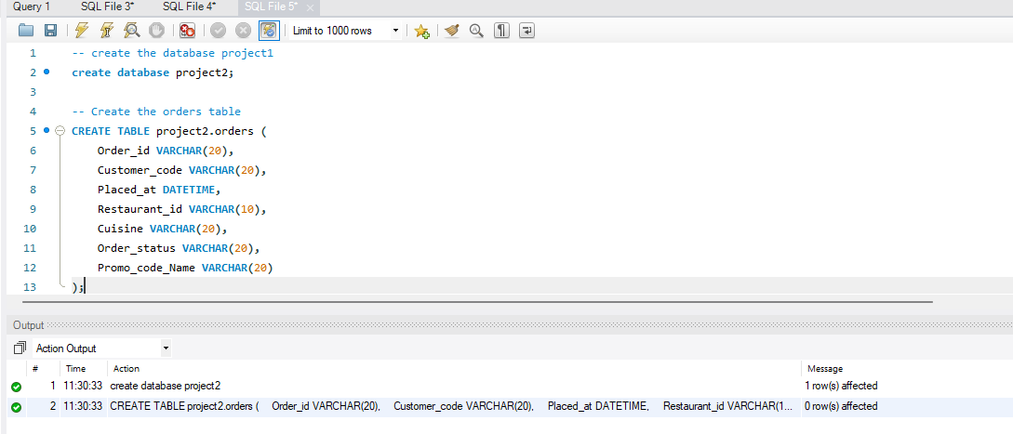

**3) Insert data into orders table**

INSERT INTO proect2.orders VALUES ('OF1900191801','UFDDN1991918XUY1','2025-01-01 15:30:20','KMKMH6787','Lebanese','Delivered','Tasty50');

INSERT INTO proect2.orders VALUES ('OF1900191802','UFDDN1991918XUY1','2025-01-02 12:15:45','LEBANESE2','Lebanese','Delivered',null);

INSERT INTO proect2.orders VALUES ('OF1900191803','UFDDN1991918XUY1','2025-01-10 18:45:30','PIZZA123','Italian','Cancelled','HUNGRY20');

INSERT INTO proect2.orders VALUES ('OF1900191804','UFDDN1991918XUY1','2025-01-15 19:20:15','ITALIAN2','Italian','Delivered',null);

INSERT INTO proect2.orders VALUES ('OF1900191805','UFDDN1991918XUY1','2025-01-20 11:30:00','BURGER99','American','Delivered',null);

INSERT INTO proect2.orders VALUES ('OF1900191806','ABC1234567890XYZ','2025-01-01 08:45:00','AMERICAN2','American','Delivered','NEWUSER');

INSERT INTO proect2.orders VALUES ('OF1900191807','ABC1234567890XYZ','2025-01-05 13:20:00','TACO789','Mexican','Delivered',null);

INSERT INTO proect2.orders VALUES ('OF1900191808','DEF9876543210XYZ','2025-01-02 09:15:00','MEXICAN2','Mexican','Delivered','FIRSTORDER');

INSERT INTO proect2.orders VALUES ('OF1900191809','GHI5678901234XYZ','2025-01-03 14:30:00','SUSHI456','Japanese','Delivered','NEWUSER');

INSERT INTO proect2.orders VALUES ('OF1900191810','JKL3456789012XYZ','2025-01-04 12:00:00','JAPANESE2','Japanese','Delivered','FIRSTORDER');

INSERT INTO proect2.orders VALUES ('OF1900191811','MNO7890123456XYZ','2025-01-05 19:45:00','KMKMH6787','Lebanese','Delivered',null);

INSERT INTO proect2.orders VALUES ('OF1900191812','PQR1234567890ABC','2025-01-06 11:30:00','LEBANESE2','Lebanese','Delivered','NEWUSER');

INSERT INTO proect2.orders VALUES ('OF1900191813','STU9876543210ABC','2025-01-07 13:15:00','PIZZA123','Italian','Delivered',null);

INSERT INTO proect2.orders VALUES ('OF1900191814','VWX5678901234ABC','2025-01-08 18:00:00','ITALIAN2','Italian','Delivered','FIRSTORDER');

INSERT INTO proect2.orders VALUES ('OF1900191815','YZA3456789012ABC','2025-01-09 12:45:00','BURGER99','American','Delivered',null);

INSERT INTO proect2.orders VALUES ('OF1900191816','BCD7890123456ABC','2025-01-10 20:15:00','AMERICAN2','American','Delivered','NEWUSER');

INSERT INTO proect2.orders VALUES ('OF1900191817','EFG1234567890DEF','2025-01-11 09:30:00','TACO789','Mexican','Delivered',null);

INSERT INTO proect2.orders VALUES ('OF1900191818','HIJ9876543210DEF','2025-01-12 14:45:00','MEXICAN2','Mexican','Delivered','FIRSTORDER');

INSERT INTO proect2.orders VALUES ('OF1900191819','KLM5678901234DEF','2025-01-13 17:30:00','SUSHI456','Japanese','Delivered',null);

INSERT INTO proect2.orders VALUES ('OF1900191820','NOP3456789012DEF','2025-01-14 12:15:00','JAPANESE2','Japanese','Delivered',null);

INSERT INTO proect2.orders VALUES ('OF1900191821','QRS7890123456DEF','2025-01-15 19:00:00','KMKMH6787','Lebanese','Delivered','NEWUSER');

INSERT INTO proect2.orders VALUES ('OF1900191822','TUV1234567890GHI','2025-01-16 10:45:00','LEBANESE2','Lebanese','Delivered',null);

INSERT INTO proect2.orders VALUES ('OF1900191823','WXY9876543210GHI','2025-01-17 15:30:00','PIZZA123','Italian','Delivered','FIRSTORDER');

INSERT INTO proect2.orders VALUES ('OF1900191824','ZAB5678901234GHI','2025-01-18 18:15:00','ITALIAN2','Italian','Delivered',null);

INSERT INTO proect2.orders VALUES ('OF1900191825','CDE3456789012GHI','2025-01-19 11:00:00','BURGER99','American','Delivered',null);

INSERT INTO proect2.orders VALUES ('OF1900191826','FGH7890123456GHI','2025-01-20 20:45:00','AMERICAN2','American','Delivered','NEWUSER');

INSERT INTO proect2.orders VALUES ('OF1900191827','IJK1234567890JKL','2025-01-21 09:15:00','TACO789','Mexican','Delivered',null);

INSERT INTO proect2.orders VALUES ('OF1900191828','LMN9876543210JKL','2025-01-22 14:30:00','MEXICAN2','Mexican','Delivered','FIRSTORDER');

INSERT INTO proect2.orders VALUES ('OF1900191829','OPQ5678901234JKL','2025-01-23 17:45:00','SUSHI456','Japanese','Delivered',null);

INSERT INTO proect2.orders VALUES ('OF1900191830','RST3456789012JKL','2025-01-24 12:30:00','JAPANESE2','Japanese','Delivered',null);

INSERT INTO proect2.orders VALUES ('OF1900191831','UVW7890123456JKL','2025-01-25 19:15:00','KMKMH6787','Lebanese','Delivered','NEWUSER');

INSERT INTO proect2.orders VALUES ('OF1900191832','XYZ1234567890MNO','2025-01-26 10:00:00','LEBANESE2','Lebanese','Delivered',null);

INSERT INTO proect2.orders VALUES ('OF1900191833','ABC9876543210MNO','2025-01-27 15:15:00','PIZZA123','Italian','Delivered','FIRSTORDER');

INSERT INTO proect2.orders VALUES ('OF1900191834','DEF5678901234MNO','2025-01-28 18:30:00','ITALIAN2','Italian','Delivered',null);

INSERT INTO proect2.orders VALUES ('OF1900191835','GHI3456789012MNO','2025-01-29 11:45:00','BURGER99','American','Delivered',null);

INSERT INTO proect2.orders VALUES ('OF1900191836','JKL7890123456MNO','2025-01-30 20:00:00','AMERICAN2','American','Delivered','NEWUSER');

INSERT INTO proect2.orders VALUES ('OF1900191837','MNO1234567890PQR','2025-01-31 09:45:00','TACO789','Mexican','Delivered',null);

INSERT INTO proect2.orders VALUES ('OF1900191838','PQR9876543210PQR','2025-01-31 14:00:00','MEXICAN2','Mexican','Delivered','FIRSTORDER');

INSERT INTO proect2.orders VALUES ('OF1900191839','STU5678901234PQR','2025-01-31 17:15:00','SUSHI456','Japanese','Delivered',null);

INSERT INTO proect2.orders VALUES ('OF1900191840','VWX3456789012PQR','2025-01-31 12:00:00','JAPANESE2','Japanese','Delivered',null);

INSERT INTO proect2.orders VALUES ('OF1900191841','JAN_ONLY_ORDER1','2025-01-15 13:30:00','KMKMH6787','Lebanese','Delivered','NEWUSER');

INSERT INTO proect2.orders VALUES ('OF1900191842','JAN_ONLY_ORDER2','2025-01-20 18:45:00','LEBANESE2','Lebanese','Delivered','FIRSTORDER');

INSERT INTO proect2.orders VALUES ('OF1900191843','NO_ORDER_LAST7_1','2025-02-01 12:15:00','PIZZA123','Italian','Delivered','NEWUSER');

INSERT INTO proect2.orders VALUES ('OF1900191844','NO_ORDER_LAST7_2','2025-02-05 19:30:00','ITALIAN2','Italian','Delivered','FIRSTORDER');

INSERT INTO proect2.orders VALUES ('OF1900191845','THIRD_ORDER_CUST1','2025-01-05 11:45:00','BURGER99','American','Delivered','NEWUSER');

INSERT INTO proect2.orders VALUES ('OF1900191846','THIRD_ORDER_CUST1','2025-01-10 14:15:00','AMERICAN2','American','Delivered',null);

INSERT INTO proect2.orders VALUES ('OF1900191847','THIRD_ORDER_CUST1','2025-01-15 17:45:00','BURGER99','American','Delivered',null);

INSERT INTO proect2.orders VALUES ('OF1900191848','THIRD_ORDER_CUST2','2025-01-10 10:30:00','TACO789','Mexican','Delivered','FIRSTORDER');

INSERT INTO proect2.orders VALUES ('OF1900191849','THIRD_ORDER_CUST2','2025-01-15 13:45:00','MEXICAN2','Mexican','Delivered',null);

INSERT INTO proect2.orders VALUES ('OF1900191850','THIRD_ORDER_CUST2','2025-01-20 16:30:00','TACO789','Mexican','Delivered',null);

INSERT INTO proect2.orders VALUES ('OF1900191851','MULTI_CUISINE_CUST','2025-01-05 12:00:00','KMKMH6787','Lebanese','Delivered','NEWUSER');

INSERT INTO proect2.orders VALUES ('OF1900191852','MULTI_CUISINE_CUST','2025-01-10 15:30:00','LEBANESE2','Lebanese','Delivered',null);

INSERT INTO proect2.orders VALUES ('OF1900191853','MULTI_CUISINE_CUST','2025-01-15 18:45:00','PIZZA123','Italian','Delivered',null);

INSERT INTO proect2.orders VALUES ('OF1900191854','MULTI_CUISINE_CUST','2025-01-20 11:15:00','ITALIAN2','Italian','Delivered',null);

INSERT INTO proect2.orders VALUES ('OF1900191855','MULTI_CUISINE_CUST','2025-01-25 14:45:00','BURGER99','American','Delivered',null);

INSERT INTO proect2.orders VALUES ('OF1900191856','SINGLE_ORDER_JAN','2025-01-10 19:00:00','AMERICAN2','American','Delivered','FIRSTORDER');

INSERT INTO proect2.orders VALUES ('OF1900191857','NO_ORDER_RECENT','2025-02-10 12:30:00','TACO789','Mexican','Delivered','NEWUSER');

INSERT INTO proect2.orders VALUES ('OF1900191858','NO_ORDER_RECENT','2025-02-15 18:00:00','MEXICAN2','Mexican','Delivered',null);

INSERT INTO proect2.orders VALUES ('OF1900191859','PROMO_FIRST_ONLY','2025-02-01 11:45:00','SUSHI456','Japanese','Delivered','WELCOME50');

INSERT INTO proect2.orders VALUES ('OF1900191860','PROMO_FIRST_ONLY','2025-02-05 14:15:00','JAPANESE2','Japanese','Delivered',null);

INSERT INTO proect2.orders VALUES ('OF1900191861','PROMO_FIRST_ONLY','2025-02-10 17:30:00','SUSHI456','Japanese','Delivered',null);

INSERT INTO proect2.orders VALUES ('OF1900191862','LAST_ORDER_7DAYS','2025-03-20 10:00:00','KMKMH6787','Lebanese','Delivered','FIRSTORDER');

INSERT INTO proect2.orders VALUES ('OF1900191863','LAST_ORDER_7DAYS','2025-03-25 13:15:00','LEBANESE2','Lebanese','Delivered',null);

INSERT INTO proect2.orders VALUES ('OF1900191864','LAST_ORDER_7DAYS','2025-03-31 16:30:00','KMKMH6787','Lebanese','Delivered',null);

INSERT INTO proect2.orders VALUES ('OF1900191865','ABC9876543210MNO','2025-02-27 15:15:00','PIZZA123','Italian','Delivered',null);

INSERT INTO proect2.orders VALUES ('OF1900191866','CDE3456789012GHI','2025-03-27 15:15:00','PIZZA123','Italian','Delivered',null);

INSERT INTO proect2.orders VALUES ('OF1900191867','ABC9876543210MNO','2025-03-15 15:15:00','LEBANESE2','Lebanese','Delivered',null);

INSERT INTO proect2.orders VALUES ('OF1900191868','ZZZ9876543210MNO','2025-03-20 15:15:00','LEBANESE2','Lebanese','Delivered','NEWUSER');

INSERT INTO proect2.orders VALUES ('OF1900191869','UFDDN1991918XUY1','2025-03-28 11:30:00','BURGER99','American','Delivered',null);

INSERT INTO proect2.orders VALUES ('OF1900191870','MULTI_CUISINE_CUST','2025-03-31 14:45:00','PIZZA123','Italian','Delivered',null);

INSERT INTO proect2.orders VALUES ('OF1900191871','DEF9876543210XYZ','2025-03-02 09:15:00','KMKMH6787','Lebanese','Delivered','TASTY50');

INSERT INTO proect2.orders VALUES ('OF1900191872','UVW7890123456JKL','2025-02-25 19:15:00','KMKMH6787','Lebanese','Delivered','TASTY25');

INSERT INTO proect2.orders VALUES ('OF1900191873','UVW7890123456JKL','2025-03-25 19:15:00','PIZZA123','Italian','Delivered','TASTY50');

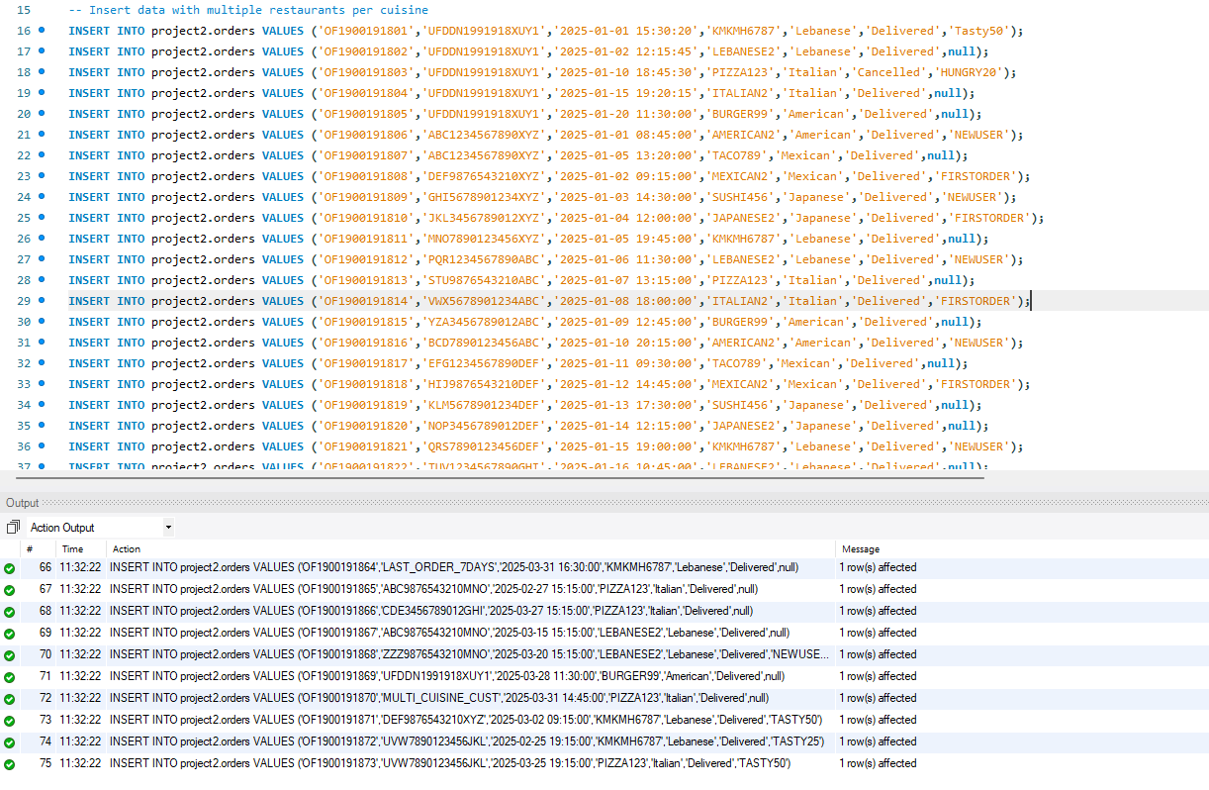

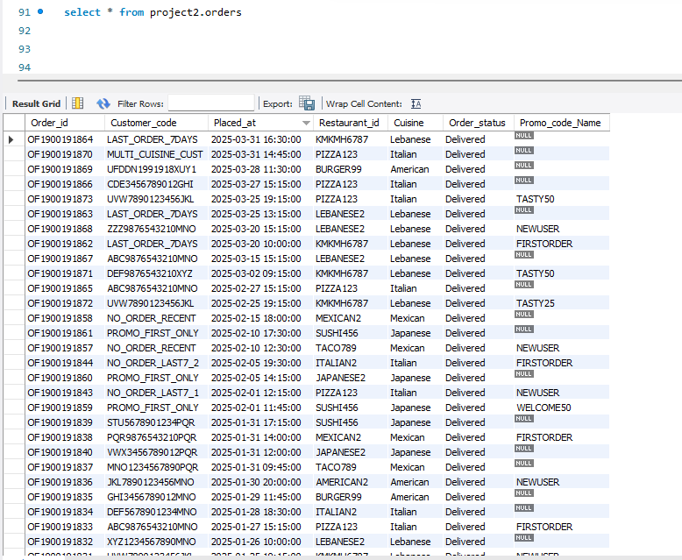

**4) Find top 3 restaurants for each cuisine based on no of orders**

select * from (

select a.*, row_number() over(partition by cuisine order by order_count desc) as rnk

from (select distinct cuisine, Restaurant_id, count(order_id) as order_count

from project2.orders

group by cuisine, Restaurant_id) a

) b

where rnk <= 3

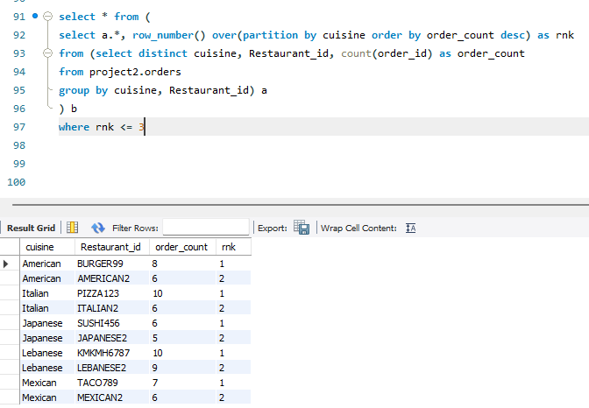

**5) Find the total customers per day and then find how many new customers placed order in each day**

select ordered_date, sum(total_customer_count) as total_customer_count, sum(new_customer_count) as new_customer_count from (

select ordered_date, count(Customer_code) as total_customer_count,

case when is_new_customer = 'Yes' then count(Customer_code) else 0 end as new_customer_count

from (

select cast(a.Placed_at as date) as ordered_date, a.Customer_code,

case when a.Placed_at > b.first_ordered_date then 'No' else 'Yes' end as is_new_customer

from project2.orders a

left join (select Customer_code, min(Placed_at) as first_ordered_date

from project2.orders

group by Customer_code) b

on a.Customer_code = b.Customer_code

order by ordered_date

) c

group by ordered_date, is_new_customer

) d

group by ordered_date

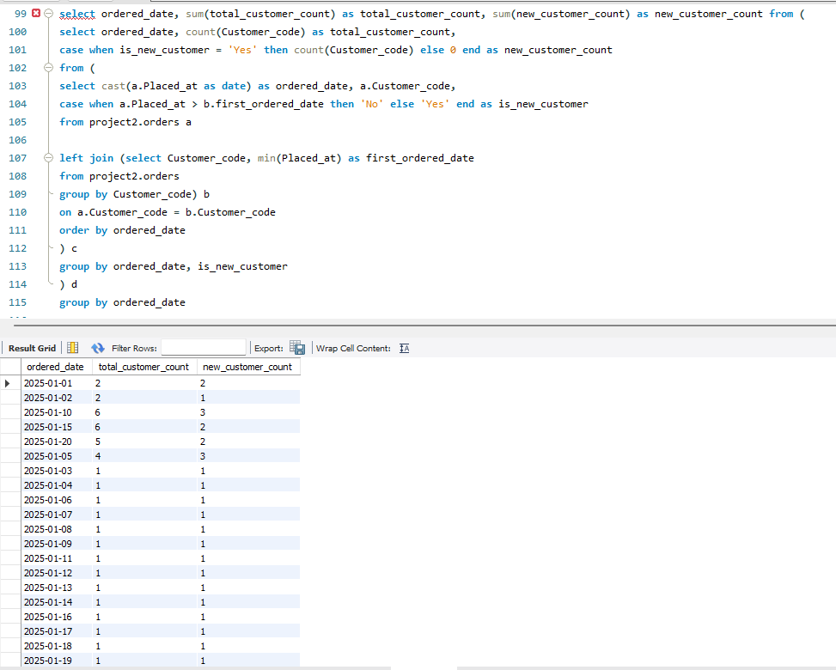

**6) Find the customers placed orders in Jan 2025 and only placed one order in Jan 2025 but not placed any other order**

select distinct a.Customer_code

from project2.orders a

left join (select Customer_code, count(Order_id) as order_count

from project2.orders

where CONCAT(YEAR(Placed_at), '-', MONTH(Placed_at)) = '2025-1'

group by Customer_code) b

on a.Customer_code = b.Customer_code

left join (select distinct Customer_code

from project2.orders

where CONCAT(YEAR(Placed_at), '-', MONTH(Placed_at)) <> '2025-1') d

on a.Customer_code = d.Customer_code

where b.Customer_code is not null and b.order_count = 1 and d.Customer_code is null

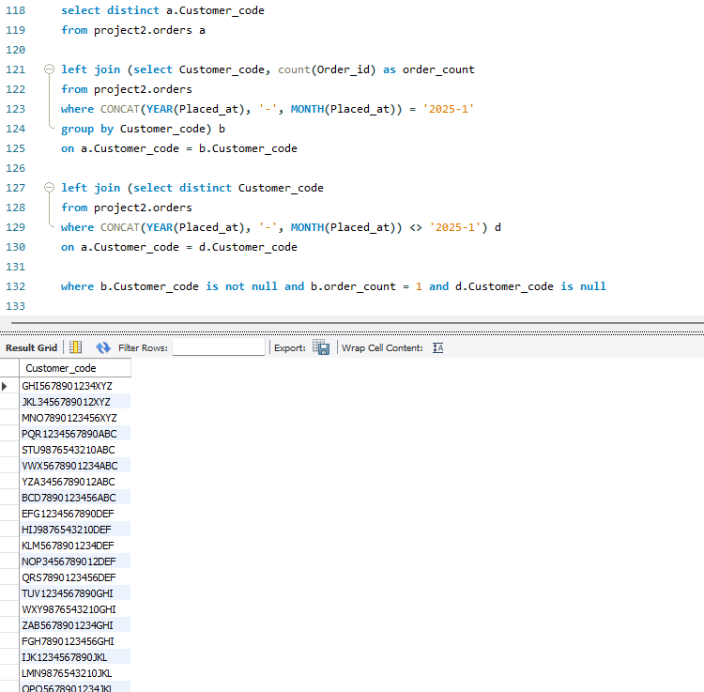

**7) Find the customers who didn't placed any order in last 7 days but acquired first order 1 month ago with promo**

select distinct Customer_code

from project2.orders

where Customer_code in (select distinct Customer_code from project2.orders group by Customer_code having max(placed_at) < date_add('2025-03-31', interval -7 day))

and Customer_code in (select distinct Customer_code from project2.orders where Promo_code_Name is not null group by Customer_code having min(placed_at) < date_add('2025-03-31', interval -1 month))

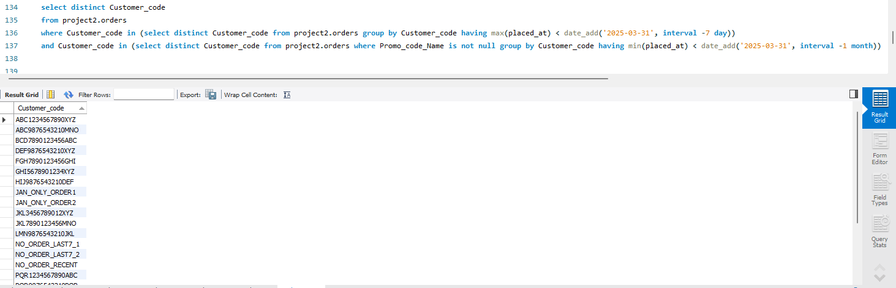

**8) Write a query to fetch customer details who have placed minimum 3 orders and get the ordered date when the customer orders every 3rd order. This helps to send them personalized message after every 3rd order.**

select a.* from (

select *,

row_number() over(partition by Customer_code order by placed_at) as rnk

from project2.orders) a

where rnk % 3 = 0 -- this condition ensures that we are checking every 3rd order placed by each customer

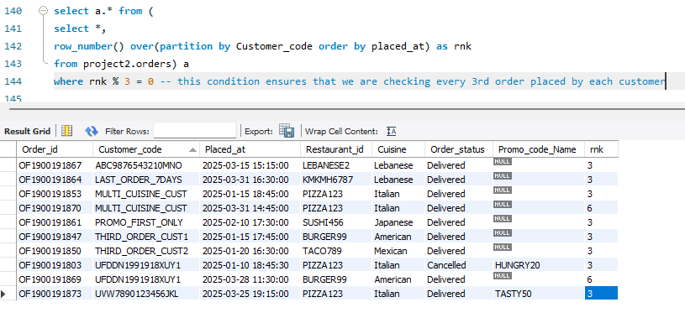

9) Find customers who placed multiple orders and all of them are with promo code

select distinct Customer_code, count(*) as total_orders, count(Promo_code_Name) as orders_with_promo

from project2.orders

group by Customer_code having count(*) > 1 and count(*) = count(Promo_code_Name)

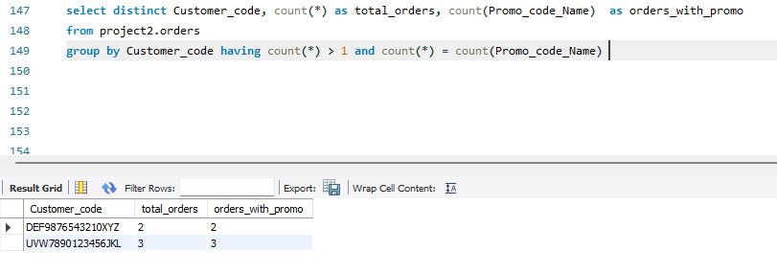

**10) What percent of customers acquired in Jan 2025 where their first order was placed without promo**

select d.*,

round((customers_without_promo_code / total_customers) * 100, 2) as percentage_without_promo from

(select count(distinct a.Customer_code) as total_customers, count(distinct b.Customer_code) as customers_without_promo_code

from project2.orders a

left join (select c.* from (select distinct Customer_code,

row_number() over(partition by Customer_code order by placed_at) as rnk

from project2.orders

where Promo_code_Name is null

and month(placed_at) = 1 and year(placed_at) = 2025) c where rnk = 1) b

on a.Customer_code = b.Customer_code

where month(a.placed_at) = 1 and year(a.placed_at) = 2025

) d

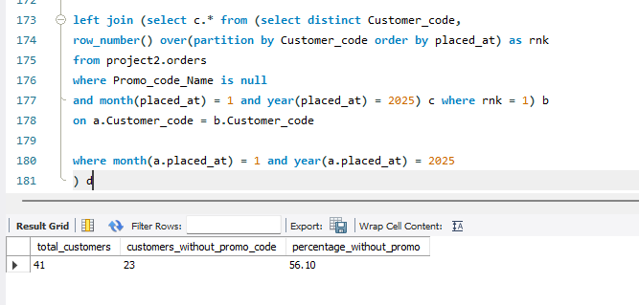

**11) Create a query to extract KPIs for total_orders, weekend_orders, week_orders, percentage_of_weekend_orders, promo_orders, percentage_of_promo_ordersfor each cuisine**

select cuisine, sum(total_orders) as total_orders,

sum(weekend_orders) as weekend_orders,

sum(week_orders) as week_orders,

round((sum(weekend_orders) / sum(total_orders)) * 100, 1) as percentage_of_weekend_orders,

sum(promo_orders) as promo_orders,

round((sum(promo_orders) / sum(total_orders)) * 100, 1) as percentage_of_promo_orders

from (

select cuisine, count(*) as total_orders,

case when dayofweek(placed_at) in (1, 7) then count(*) else 0 end as weekend_orders,

case when dayofweek(placed_at) not in (1, 7) then count(*) else 0 end as week_orders,

case when Promo_code_Name is not null then count(*) end as promo_orders

from project2.orders

group by cuisine, placed_at, Promo_code_Name) a

group by cuisine

